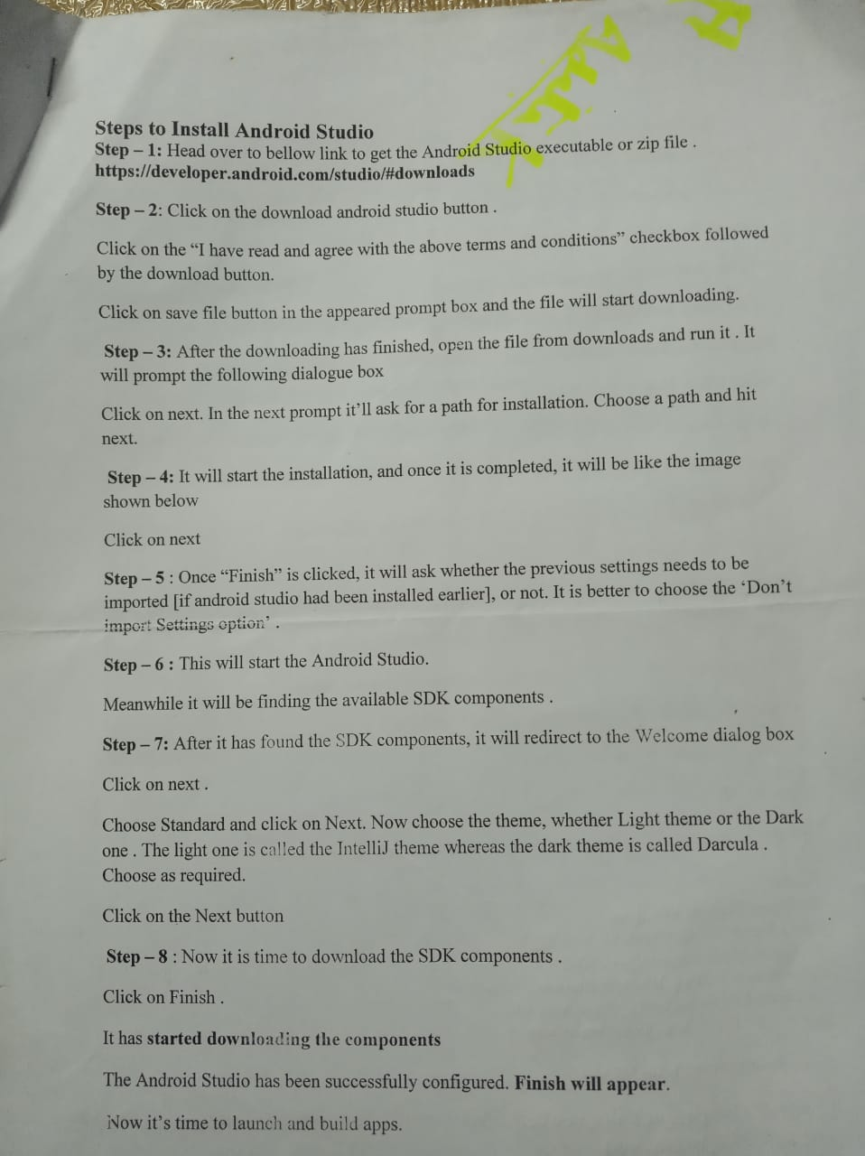

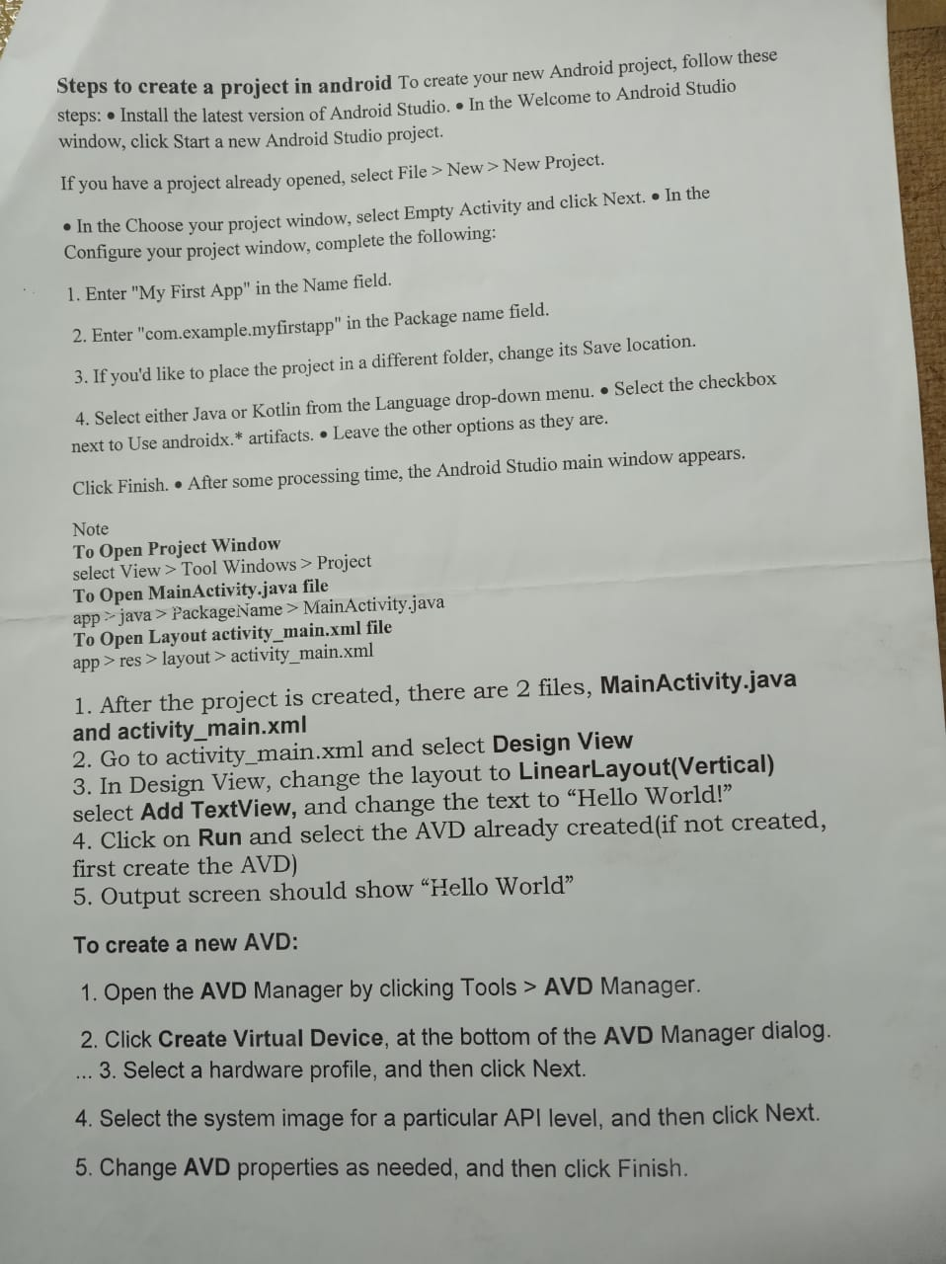

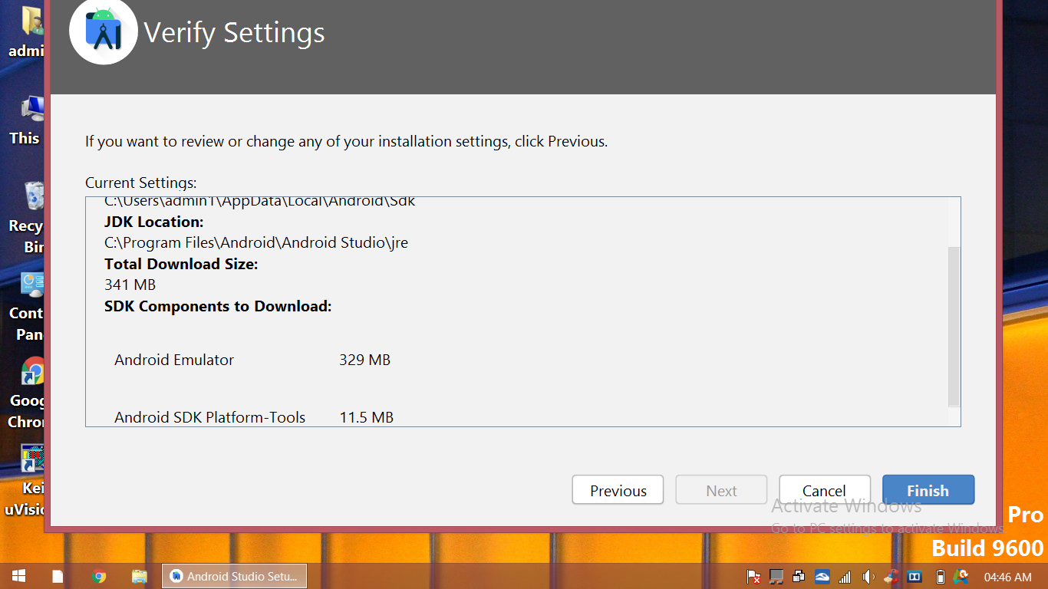

**How to open app in mobile:**

Click 7 times on settings of device on mobile

it will add developer mode

then enable developer mode.

send .apk file to your phone via whatsapp

and install .apk file

it will create icon of your .apk

and see the output